Air Fin Cooler
Air fin cooler equipped with fin on the outer surface of the tube to widen heat transfer area. Process fluid flows in the tube and cooling air is flowed by fan through tubes, to cool the specified amount of heat contained in the process fluid.
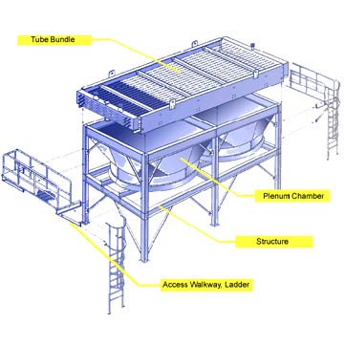
System Configuration
The air fin cooler system consists of the following major components;
A Tube bundle
B Chamber
C Structure
D Access walk way ladder

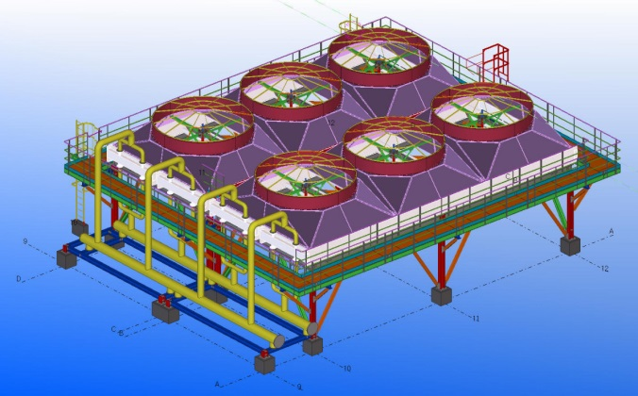
Feature and Benefit
Air Fin Cooler is heat exchanger that forces air into the tubes through which the fluid flows, thereby forcing heat exchanger.
Energyen’s design has been improved and updated continually by client and incorporated with many features that assure the good efficiency and reliable performance.

Air Fin Cooler has the following advantage.
- No problem arising from thermal & chemical pollution of cooling fluids.
- Air is always available.
- Fouling on air side can normally be ignored. And maintenance cost normally less than for water cooled systems.

Air fin Cooler Module
● Bundle design ● Structure design
● Rotating parts design ● Louver design
● Steam coil design
-
Finned Tube type
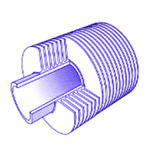
● Embedded - ”G” ● Extruded - “Ext”
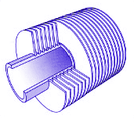

● ‘L’ Footed - “L” ● Double ‘L’ – “LL”
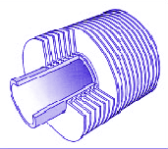
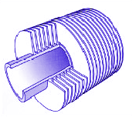

Air Fin Cooler Assembly
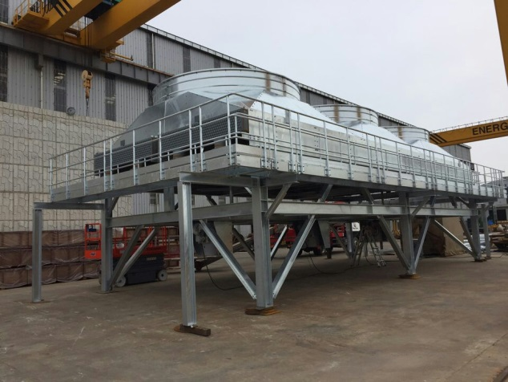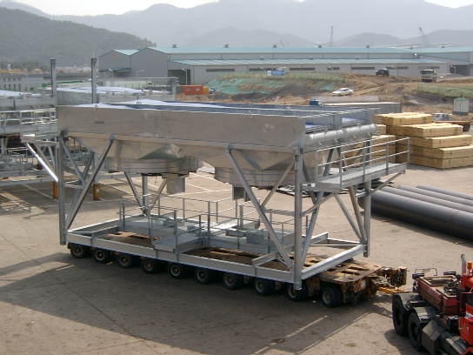
● Induce type ● Forced type

